HS2-005 Life Vest Risk Assessment CO₂ Lifejacket Service Record Sheet
Jacket Make and Model: Parmaris 150N (Blue)
Jacket Serial Number: 797129
Date | Visual Inspection | Leak Test (min 12 hours) | CO2 Cylinder Weight (g) | Cylinder Condition | Auto Inflator Check | Checked By | Comments
Feb 2025 | OK | Passed | New | New | Replaced | D Holmes | Complete Service, new cylinder, inflator and clips

Jacket Make and Model: Parmaris 150N (Green)
Jacket Serial Number: 790139
Date | Visual Inspection | Leak Test (min 12 hours) | CO2 Cylinder Weight (g) | Cylinder Condition | Auto Inflator Check | Checked By | Comments
Feb 2025 | OK | Passed | New | New | Replaced | D Holmes | Complete Service, new cylinder, inflator and clips

Jacket Make and Model: xxx
Jacket Serial Number: xxx
Date | Visual Inspection | Leak Test (min 12 hours) | CO2 Cylinder Weight (g) | Cylinder Condition | Auto Inflator Check | Checked By | Comments

Jacket Make and Model: xxx
Jacket Serial Number: xxx
Date | Visual Inspection | Leak Test (min 12 hours) | CO2 Cylinder Weight (g) | Cylinder Condition | Auto Inflator Check | Checked By | Comments

CO₂ Lifejacket Service Procedure
Introduction
Regular servicing and maintenance of your CO₂ inflatable lifejacket are essential to ensure it functions correctly in an emergency. This guide provides step-by-step instructions on how to service your lifejacket and includes a service record sheet to document inspections.

Service Frequency
It is recommended that you check your CO₂ inflatable lifejacket:
- Before every use – A visual inspection.
- Every six months – A visual inspection of the inflator cartridge inside the RHS of the jacket.
- Every 2 years – A full service including an inflation test.

Tools & Materials Needed
- Dry cloth
- Weighing scale (for CO₂ cylinder check)
- Replacement CO₂ cylinder (if required)
- Replacement inflator cartridge
- Freshwater for rinsing (if used in saltwater)
- Weighing scale (for CO₂ cylinder check)

Step-by-Step Service Guide
1. Visual Inspection
- Check the fabric and seams for cuts, abrasions, or punctures.
- Inspect the straps and buckles for wear or damage.
- Ensure reflective tapes and whistle are intact and securely attached.
2. CO₂ Cylinder Check
- Unscrew the CO₂ cylinder and inspect for corrosion or damage.
- Weigh the cylinder using a scale; compare the weight to the stated value on the cylinder.
- If the cylinder is damaged or underweight, replace it with a new one of the correct size.
- Ensure the cylinder is securely screwed back into place.

3. Automatic Inflation Mechanism (if applicable)
- Inspect the automatic firing mechanism for expiry dates.
- Check the inflator cartridge for signs of damage or deterioration.
- Check the cartridge indicator for status (see below)
- Replace if necessary and ensure correct reassembly, referring to the attached manual
How the Indication System Works
The indication on the standard MK5 Automatic inflator allows the user to establish if the system has been fired. The standard MK5 Automatic inflator does not indicate if a pierced CO2 cylinder is accidentally refitted to the inflator during the servicing procedure. The CO2 cylinder must be checked each time you don your lifejacket to ensure it is not pierced and it is tightly screwed in by hand. In addition the cartridge must be checked to ensure it has not passed the replace by date, it is also fully screwed on tightly by hand and water is not restricted from entering the system.
There are 2 forms of indication :
- The Automatic Indicator
- The Manual Indicator
Both indications must be green, the Automatic Cartridge must be screwed on hand tight and must be within the printed Replace By Date and a fully screwed in hand tight, full CO2 Cylinder for correct operation.
The Automatic Indicator is positioned on the base of the Automatic Firing Mechanism.
GREEN indicates OK, and RED indicates STOP/NOT USABLE.
The Manual Indicator is positioned on the side of the firing head.
GREEN indicates OK, and RED indicates STOP/NOT USABLE.
These should checked each time the lifejacket is worn.
If either or both of these indicators are red or missing please refer to the Re-arming tab above.

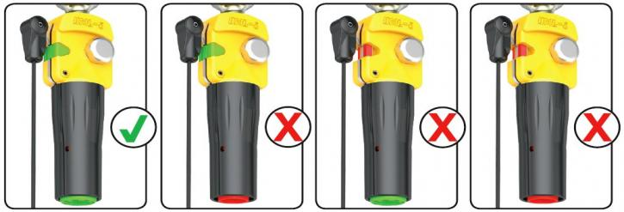

4. Manual Inflation Test
- Fully inflate the lifejacket using the oral inflation tube.
- Leave it inflated for 12 to 24 hours to check for leaks.
- If the pressure drops, submerge the lifejacket in water and look for bubbles to identify leaks.
- If bubbles can be seen, discard the jacket and replace.
- If no bubbles can be seen, reinflate jacket and recheck, if pressure drops again discard the jacket.
- Deflate using the oral tube, ensuring all air is expelled.
5. Repacking the Lifejacket
- Only repack a jacket that maintains pressure for at least 12 hours.
- Ensure the bladder is fully deflated and dry.
- Fold and pack according to the manufacturer’s guidelines.
- Ensure the manual pull cord is accessible.
- Secure all Velcro and fastening points.
6. Final Checks
- Ensure the lifejacket is clean and dry before storage.
- Store in a cool, dry place away from direct sunlight and chemicals.
- Record the service in the log sheet.
